

ERBB2 (D769H)
Catalog Number: CR-M26381
Gene Symbol: ERBB2/HER2/Neu/c-Neu
Description: Anti-ERBB2 (D769H) Mouse Monoclonal Antibody

Background: The HER-2/neu oncogene, a member of the epidermal growth factor receptor or erb-B gene-like family, encodes a transmembrane tyrosine kinase receptor that mediates extracellular signals activated by epidermal growth factors. Her2 abnormal has been strongly associated with many malignant tumors, especially with breast cancers. The expression level of Her2 is an important critiria in clinic evaluating of the progression of breast cancer.
Immunogen: A synthetic peptide from the internal region of ERBB2 which includes the mutation of D769H, human origin.
Tested applications: ELISA, WB, IHC Recommended dilutions:
ELISA: 1:1000-1:2000
WB: 1:500-1:1000
IF: 1:25-1:50
Concentration: 1 mg/ml
Host: Mouse
Clonality: Monoclonal
Purity: Purified from ascites
Format: Liquid Storage buffer:
Preservative: no
Constituents: PBS (without Mg2+ and Ca2+), pH 7.4, 150 mM NaCl, 50% glycerol
Species Reactivity: Recognizes D769H mutant, but not wild-type ERBB2 of vertebrates.
Storage Conditions: Store at -20°C. Avoid freeze / thaw cycles.

Western blot:
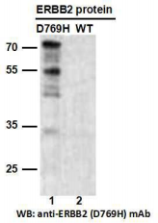
Western blot analysis of recombinant ERBB2 (D769H) and wildtype proteins. Purified
His-tagged ERBB2 (D769H) protein (lane 1) and corresponding wildtype protein (lane 2) were
blotted with anti-ERBB2 (D769H) monoclonal antibody (Cat. #26381).

For research use only. Not for diagnostic or therapeutic applications.

Immunofluorescence:
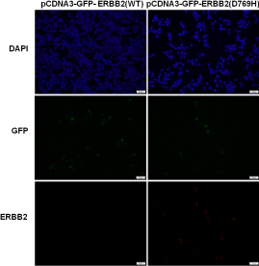
Immunofluorescence of cells expressing
ERBB2 proteins with anti-ERBB2 (D769H)
antibody. HEK293T cells were transfected with pCDNA3-GFP-ERBB2 (WT) plasmid (left
column) or pCDNA3-GFP-ERBB2 (D769H)
plasmid (right column), then fixed and stained
with anti-ERBB2 (D769H) monoclonal antibody (Cat. #26381).

科博瑞（武汉）生物科技有限公司
TEL：027-87615885 15972062685
- mail：3636901710@qq.com
Web:www.coburybio.com

